|  |
| --- |
| Final Year Project |
| **Script Generator** |
| Useful and Productive for SQL Server |



|  |
| --- |
|  |

Project Member:

Arsalan Ahmed Khan

Shahzad Ansari

Zubair Hussain

Introduction:

Scrip Generator is very productive in profession and business environment because of we can easily generate INSERT and UPDATE Query with WHERE Clause .Many number of times wrong data may be inserted due to system bug or ignore many properties of control and in the system this is the blunder when using distributive system because wrong data may be sent to many distributed server and distributed server also communicate wrong data. This project addressed where one of the requirements was to write stored procedures from scratch for inserting and updating data in all the available tables in SQL Database.

Platform Required:

The project is developed using C# WPF in .NET Framework 4.0 and communicate with SQLSERVER. This generates insert and update script, which you can modify according to your requirement. This project is so productive and time saving when you want to write insert and update query.

Controls Required:

1. TreeView
2. CheckBox
3. Button
4. ComboBox
5. TextBox
6. TextBlock

Project Detail:

When we open the project file below window is shown:

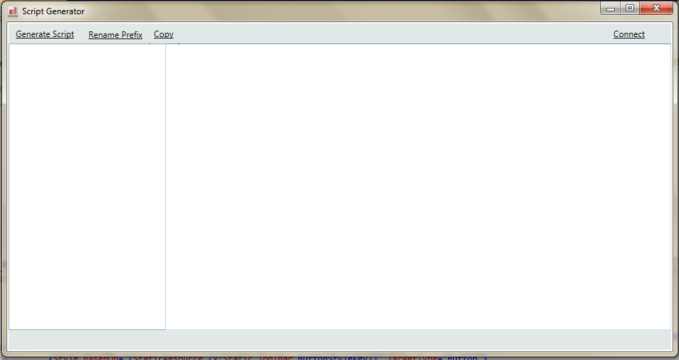

As you can see in the above window, there are four buttons (Connect, Generate Script, Rename Prefix and Copy) and below is the explanation of all buttons respectively.

Connect (Button):

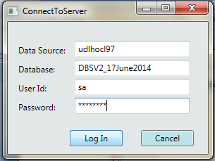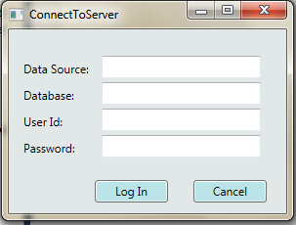First you to connect the Server (machine) ,Database where you have the table objects for which you want to generate stored procedure. When you enter Connect button Log In window appear shown below:

Fig.1(a)-Empty Login Form Fig.1(b)- Login Form with Login Information

In above Fig.1 (a) you can define your Data Source or Machine name where your database exist and your database name where you table objects exist and its user id and password of the database then click button Log In. And Fig.1(b) shows form with the required information. After click on “Log In" button. Once connected successfully to the SQL Server, it will show all the table objects of database as shown in the below Fig.2(a)

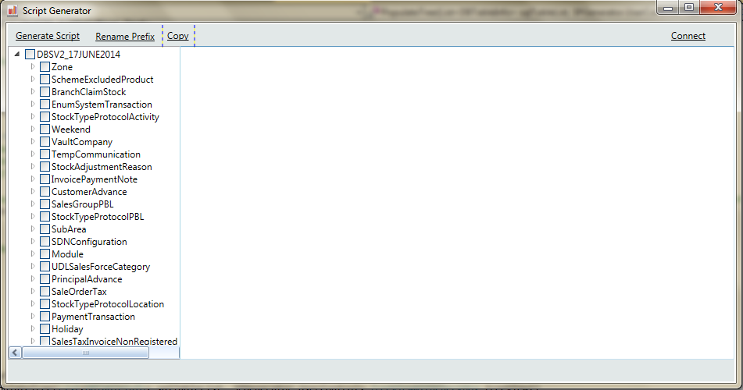

Fig.2- Populated TreeView Control with Table Objects Name

Generate Script (Button):

In Fig.2 see only if you connected the SQL Server and TreeView populated with database name as root node and when you expand there is the number of tables present. After selecting the any of the table object checkbox and click on “Generate Script” button then Query is generated, below Fig.3(a) and Fig.3(b) represent the window look after click “Generate Script” button.

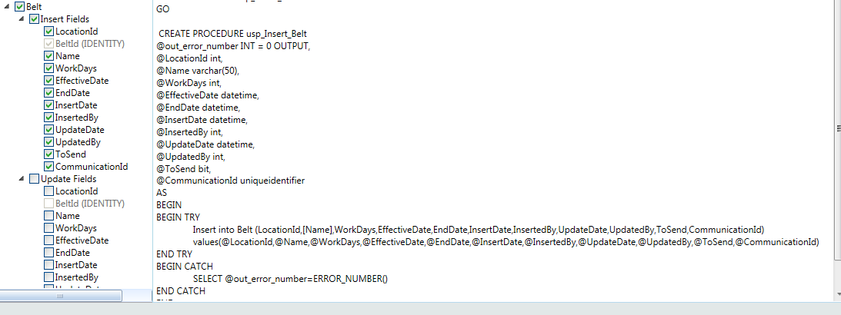

Fig.3(a)-Generate Insert Query after Clicking button

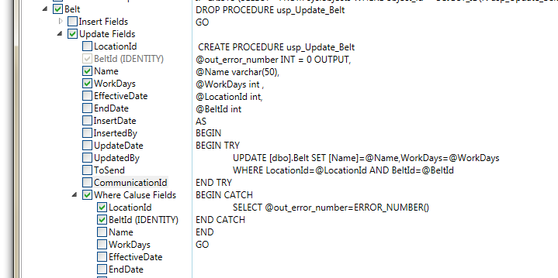

Fig.3(b)-Generate Update Query with WHERE Clause after Clicking button

Rename Prefix (Button):

Using this button, you can modify variable and stored procedure prefix. When you Click the button below window appear on screen.

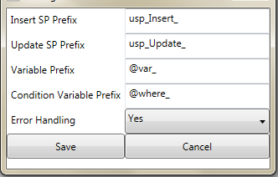

Fig.4-Rename Prefix Window with define values

Here Error Handling field allows you to enable/disable error handling, if this contain “Yes” then stored procedure will contain Try-Catch block else your stored procedure will not contain Try-Catch block.

After Clicking “Save” button then Click “Generate Script” button then prefix changed, in the below Fig.3(c) you can see the change.

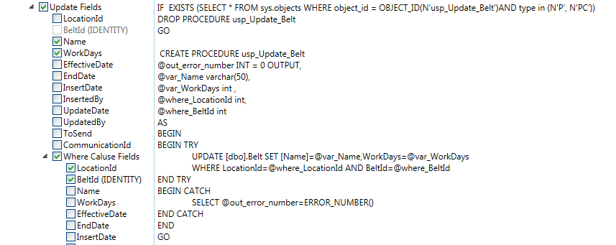

Fig.3(c)-Variable and Stored Procedure Prefix changed as you defined

Copy (Button):

This button will copy SP generated in Windows clipboard which you can easily paste on SQL Server and your work or task is completed, in the below SQL Server window shown the last step of the process.

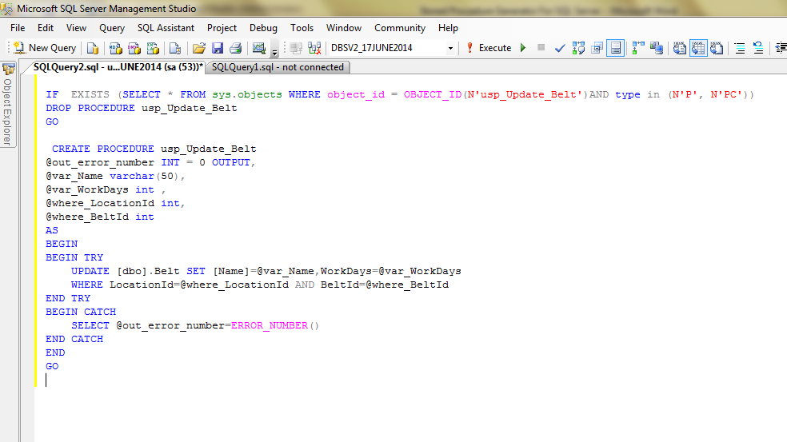

Conclusion:

This is very productive to create stored procedure and time saving to generate query with exception handling, in development and as per your requirement to update any field through backend not making stored procedure only you can use this query with the definition variables and little bit modification required, as the below screenshot.

